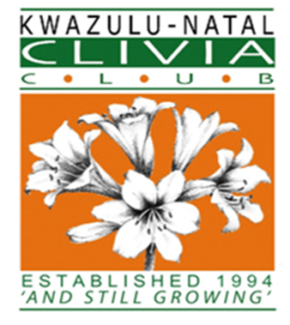

Good Day

On the 1st of October 2022 the KZNCC will be hosting a Learner Judge Workshop at Glen and Liz Boyd’s Karkloof Clivias, Howick. The invitation is extended to KZNCC Members as well as interested Clivia Society members from other Clubs.

The participating Judges are all Clivia Society Judges and the facilitator of this Learner Judge Workshop will be Sean Chubb. The workshop is for Learner Judges, but the opportunities also exist for participants to interact with Growers with a wealth of knowledge and experience in growing and caring for Clivias.

Attached, please find the guidelines as to what are required for a person to become a judge and the application form. If you think you have what it takes to become a Judge, complete the application and return it to the email address provided below. **Closing date for applications is the 25/09/2022**

Forward your completed application form to [KZNCLIVIACLUB@gmail.com](mailto:KZNCLIVIACLUB@gmail.com) or luke@btapipe.co.za

Learner Judges attending the workshop will receive a Certificate of Attendance.

Venue:                          Karkloof Clivias, see below for directions

Date:                             01/10/2022

Time:                            9am

Registration Fee:         R100.00

Banking details:

KZN Clivia Club

Nedbank    198765

1519992858

Ref:   L/W + Name and Surname

Regards

KZNCC

**Karkloof Clivias Liz Boyd (0828252124)**

**Directions**